Supporting Information

**Tuning the ionic character of sodium dodecyl sulphate via counter-ion binding: an experimental and computational study**

Germán Pérez-Sánchez1*, Nicolas Schaeffer1, Tamar L. Greaves2, Jorge F. B. Pereira3 and João A. P. Coutinho1

1CICECO – Aveiro Institute of Materials, Department of Chemistry, University of Aveiro, 3810-1933 - Aveiro, Portugal

2STEM College, RMIT University, 124 La Trobe Street, Melbourne, Victoria, Australia

3University of Coimbra, CIEPQPF, Department of Chemical Engineering, Rua Sílvio Lima, Pólo II – Pinhal de Marrocos, 3030-790 Coimbra, Portugal

**\* Correspondence:** gperez@ua.pt

**Table of contents**

**Figure S1.** Chemical structures of the components used in the CG-MD simulations and the CG mapping scheme with the selected MARTINI 2.2 bead types.

**Figure S2.** CG-MD simulation snapshot for the 2%wt of SDS concentration in aqueous solution and CG-MD simulation snapshot for the 6%wt [N4,4,4,4]Cl concentration in aqueous solution at. The averaged density profile of each CG bead type is also shown.

**Figure S3.** a) Experimental aggregate size distribution estimated by DLS. b) NMR measurements displaying the shift of the mixture relative to that of the pure compounds in water.

**Figure S4**. CG-MD simulation snapshots after 1.5 μs for a) 0.3, b) 0.5 and c) 1.0 [N4,4,4,4]+/[DS]- molar ratios in a 2 wt% SDS aqueous solution at 298K.The color code is the same as in **Figure S2**.

**Figure S5**. CG-MD simulation snapshots over 1.5 μs for 0.1, 0.3, 0.5, 0.7 and 1.0 [N4,4,4,4]+/[DS]- molar ratios in a 2 wt% of SDS aqueous solution at 298 K.

**Table S1.** Number of compounds used in the CG-MD simulations at 0.1, 0.3 0.5, 0.7 and 1.0 [N4,4,4,4]+/[DS]- molar ratios in a 2 wt% of SDS aqueous solution.

**Figure S6.** Detailed perspective of the SDS Sulphur charged headgroups, sodium and chloride counterions of the density profiles at the aggregate surface for the 0.1, 0.3, 0.5, 0.7 and 1.0 [N4,4,4,4]+/[DS]- molar ratios systems shown in **Figure 3**.

**Figure S7.** Experimental SAXS profiles as a function of the [N4,4,4,4]+/[DS]- molar ratios.

**Figure S1.** Chemical structures of the components (top) used in the CG-MD simulations and the CG mapping scheme with the selected MARTINI 2.2 bead types.(1) The SDS- consists of three C1 beads for the alkyl tail displayed in green and the hydrophilic Sulphur charged head group shown in purple. The [N4,4,4,4]Cl entails three C3 beads for the butyl groups, shown in orange color, linked to the charged ammonium center mapped with one Q0 bead shown in light red. The chloride Cl- (Qd) and Na+ (Qa) beads implicitly include six water molecules emulating the first solvation shell and are colored in yellow and grey, respectively. The water model consists on P4 and BP4 beads which implicitly includes four water molecules and are colored in blue.(1)

**Figure S2**. a) CG-MD simulation snapshot for the 2 wt% concentration of SDS in aqueous solution displaying micelles with an averaged aggregation number of 60 at 298K after 3 μs of simulation time. The averaged micelle density profile is shown on the right where alkyl tails, purple Sulphur charged headgroups, chlorides and water are colored in green, purple, black, and blue, respectively. b) CG-MD simulation snapshot for the 6 wt% [N4,4,4,4]Cl concentration in aqueous solution at 298K after 3 μs of simulation. The averaged density profile of each CG bead type is shown in the left for the x-Axis of the simulation box. The color code in both are as follows: butyl groups are colored in orange, the ammonium centers are in red, and the chloride anions in yellow. The same density profile trend (not shown here) was found for Y and Z directions. The water was removed in both simulation snapshots for clarity.

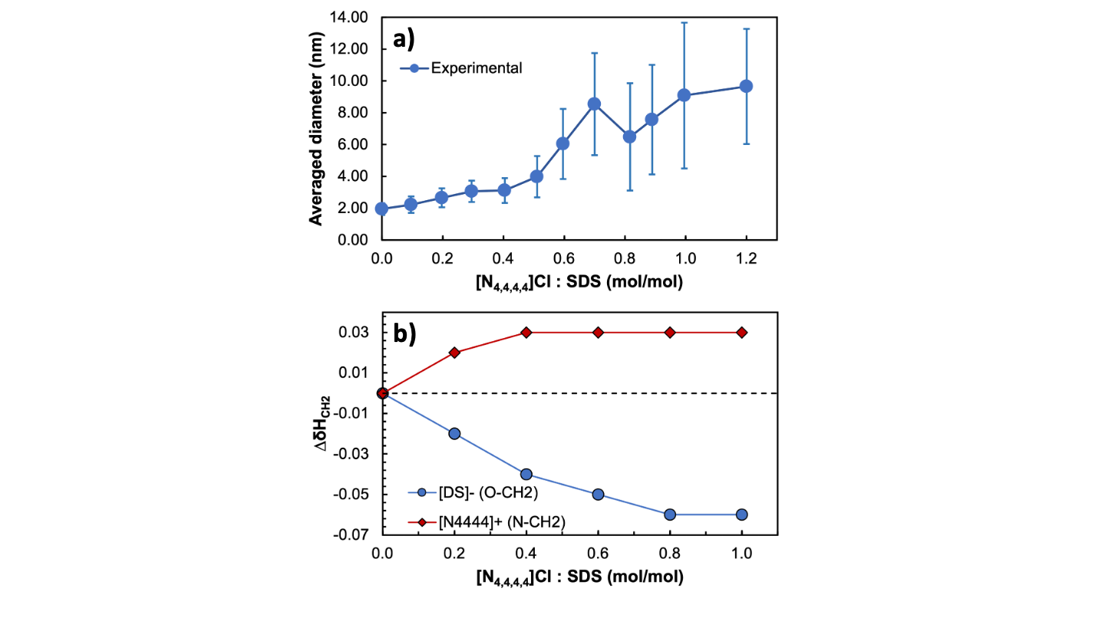

**Figure S3.** a) Experimental aggregate size distribution estimated by DLS. b) NMR measurements displaying the shift of the mixture relative to that of the pure compounds in water.

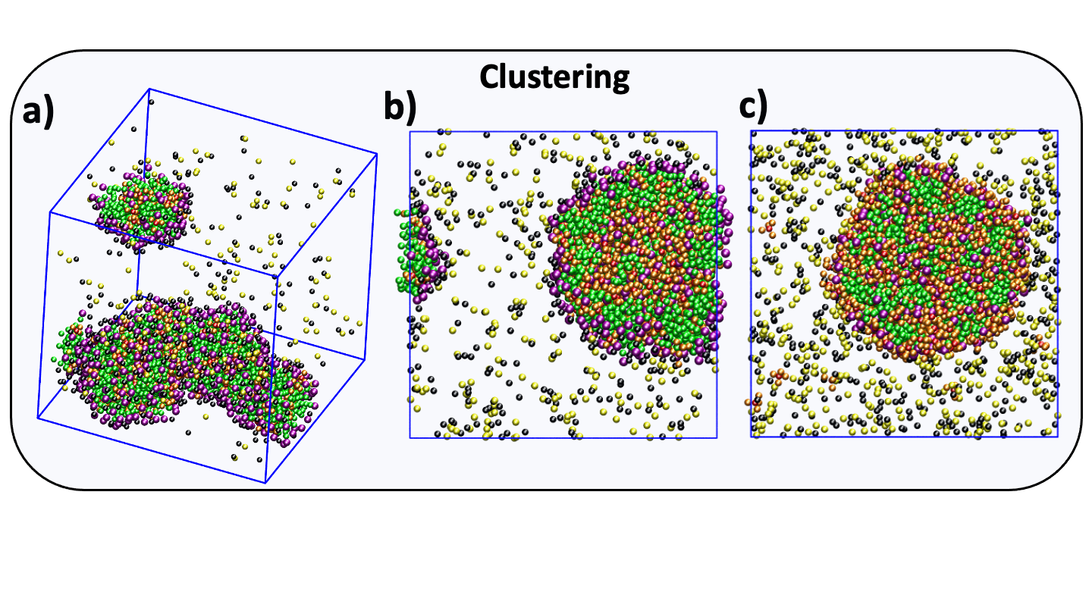

**Figure S4**. CG-MD simulation snapshots after 1.5 μs for a) 0.3, b) 0.5 and c) 1.0 [N4,4,4,4]+/[DS]- molar ratios in a 2 wt% SDS aqueous solution at 298K.The color code is the same as in **Figure S2**.

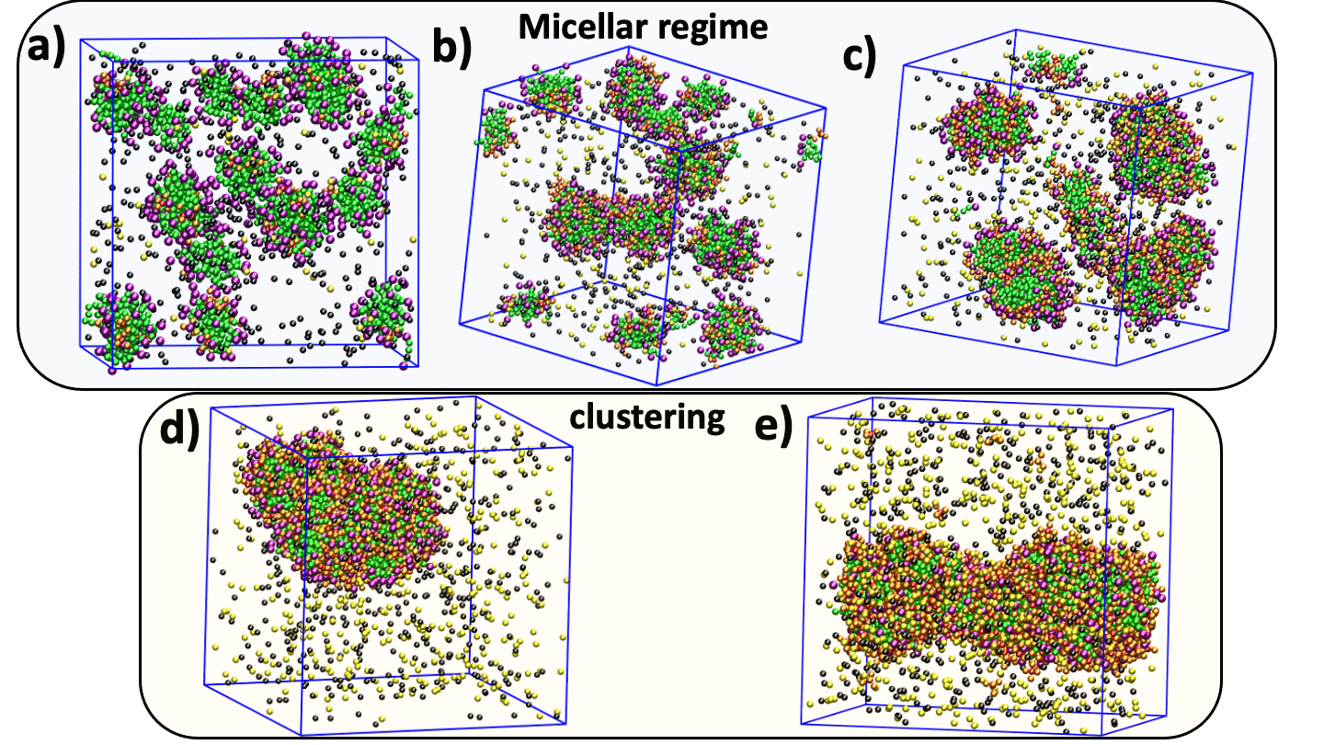

**Figure S5**. CG-MD simulation snapshots after 1.5 μs for a) 0.1, b) 0.3, c) 0.5, d) 0.7 and e) 1.0 [N4,4,4,4]+/[DS]- molar ratios in a 2 wt% SDS aqueous solution at 298K. The color code is the same as in **Figure S2**.

**Table S1.** A concentration of 2 wt% SDS in aqueous solution was selected where 0.1, 0.3, 0.5, 0.7 and 1.0 [N4,4,4,4]+/[DS]- molar ratios were used in the experiments and in the CG-MD simulations. Table shows the number of molecules used in the CG-MD simulations. W means the number of CG water beads; therefore, the total number of water molecules is 4x·105.

|  |  |  |  |
| --- | --- | --- | --- |
| [N4,4,4,4]+/[DS]- | SDS | [N4,4,4,4]Cl | W |
| 0.1 | 500 | 50 | 105 |
| 0.3 | 500 | 150 | 105 |
| 0.5 | 500 | 250 | 105 |
| 0.7 | 500 | 350 | 105 |
| 1.0 | 500 | 500 | 105 |

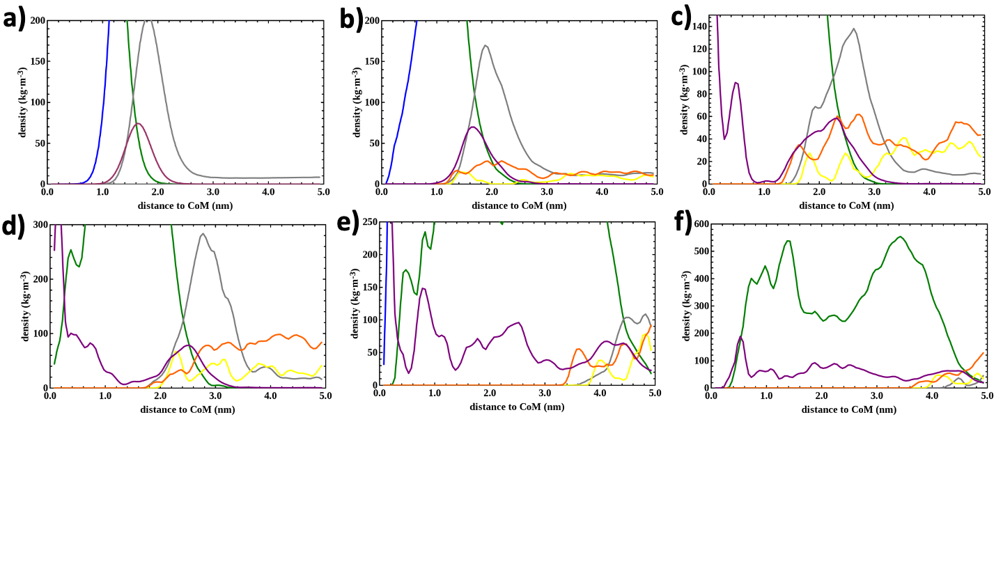

**Figure S6.** Detailed perspective of the density profiles at the aggregate surface for the a) 0.0, b) 0.1, c) 0.3, d) 0.5, e) 0.7 and f) 1.0 [N4,4,4,4]+/[DS]- molar ratios shown in **Figure 3**. The color code is as follows: [DS]- alkyl tails and Sulphur charged headgroups are colored in green and purple, respectively. Sodium, chloride and water are in grey, yellow and blue, respectively, whereas [N4,4,4,4]+ was in orange.

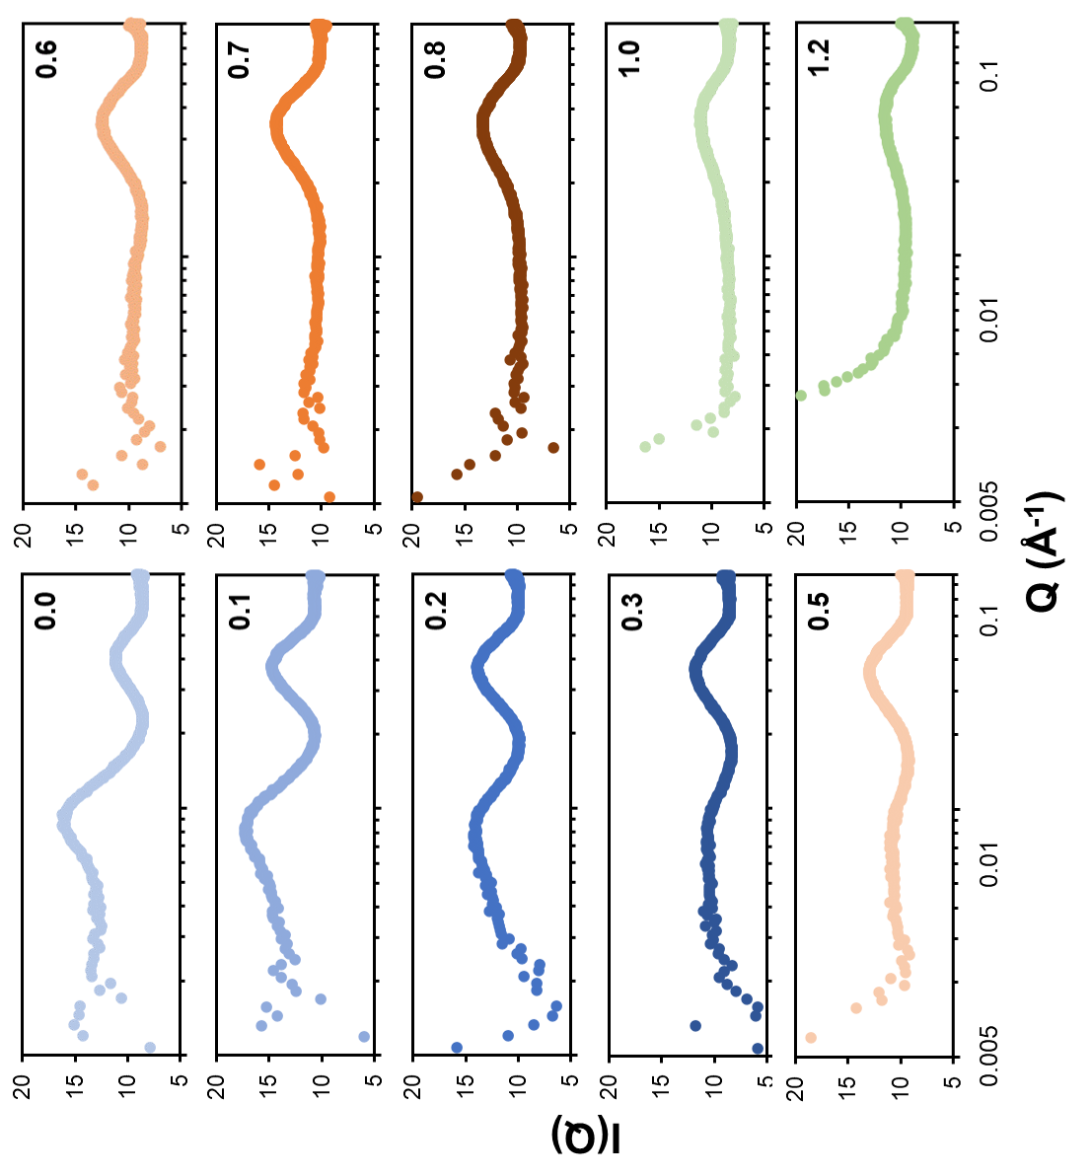

**Figure S7.** Experimental SAXS profiles as a function of the [N4,4,4,4]+/[DS]- molar ratio.

**References**

1. Marrink SJ, Risselada HJ, Yefimov S, Tieleman DP, de Vries AH. The MARTINI Force Field: Coarse Grained Model for Biomolecular Simulations. J Phys Chem B [Internet]. 2007 Jul;111(27):7812–24. Available from: http://pubs.acs.org/doi/abs/10.1021/jp071097f